Company: | Telephone:
Contact: | Telefax:
Street: | Email:
Postal code, Place: | Date:

Information

- Number of stations
- Motion time [t₁] [s] Rest time [t₂] [s]
- Motion angle [ß₁] [°]
- Drive rotates continuously
- Drive stops after every switching operation Switchings / min
- Drive reversed Yes No
- Emergency stop during the switching operation Yes No
- Inching mode during setup Yes No
- Desired service life (normally 8000h) [L_{h}] [h]
- Disc on rotary index table
- Outer Ø [D] [mm] Weight [m_{s}] [kg]
- Workpiece supports
  - Operating radius [r] [mm] Weight [m_{A}] [kg] Number
- Workpieces
  - Operating radius [r] [mm] Weight [m_{w}] [kg] Number

Mounting position

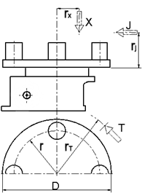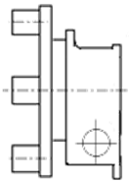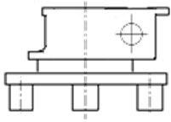
Mounting position Mounting position Mounting position

-> please turn over

- External forces during motion
(please send sketch)
- External forces during rest
(please send sketch)
- Criteria for motor selection:
  - Make: Type:
  - Area of application: Europe USA Others
  - Voltage: [V] Frequency: [Hz] Braking voltage: [V]
  - Protection class: IP54 Others
  - Thermal class: Standard ISO B Others
  - Brake with manual venting: Yes No

Remarks

