Company: | Telephone:
Contact: | Telefax:
Street: | Email:
Postal code, Place: | Date:

Information
- Stroke of the conveyor [B] for every switching operation [mm]
- Motion time [t₁] [s] Rest time [t₂] [s]
- Motion angle [ß₁] [°]
- Drive rotates continuously Drive stops after every switching operation
- Switchings /min
- Emergency stop during the switching operation Yes No
- Inching mode during setup Yes No
- Desired service life (normally 8000h) [L_{h}] [h]
- Center distance of the conveyor [A] [mm]
- Driving wheels:
  - Number of teeth Reference circle-Ø (dd₁) [mm] Unit weight [kg]
Number
- Driven wheels:
  - Number of teeth Reference circle-Ø (dd₂) [mm] [kg]
Number
- Workpieces:
  - Unit weight [kg] Number
- Supports of the workpieces
  - Unit weight [kg] Number
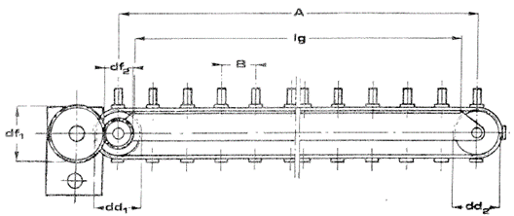
- Guide:
  - Length [l_{g}] [mm] Friction coefficient
- Transport chain or transport band
  - Graduation [mm] Number of chains
  - Weight of the individual chain [kg]
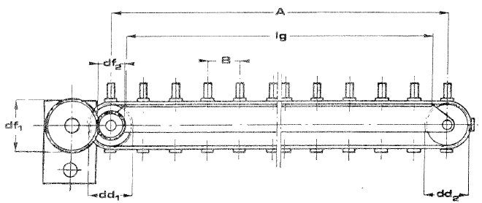
Configuration

horizontal vertical

- Possible external forces (please send sketch)
  - Size of force: [N] Impact radius: [mm]
- Possible transmission gearing on output shaft (please send sketch)
  - Transmission ratio (df_{2 :} df₁):
- Criteria for motor selection:
  - Make: Type:
  - Area of application: Europe USA Others
  - Voltage: [V] Frequency: [Hz] Braking voltage: [V]
  - Protection class: IP54 Others
  - Thermal class: Standard ISO B Others
  - Brake with manual venting: Yes No

Remarks

